**As-Is Process Models:** Three main processes have been identified in the creation of a surgery event. Firstly, when an event is planned, a location is selected and its site privileges are determined. Secondly, volunteers are added and sorted and selected. The volunteers are selected and sorted by hand through an excel spreadsheet, and if they do not have privilege to work at the host location, then another volunteer must be selected. Lastly, funds via donations or grants or procured to fund the event. When all three processes are completed, a surgery event is created. The current process is tedious, time-consuming, and has room for improvement in organization.

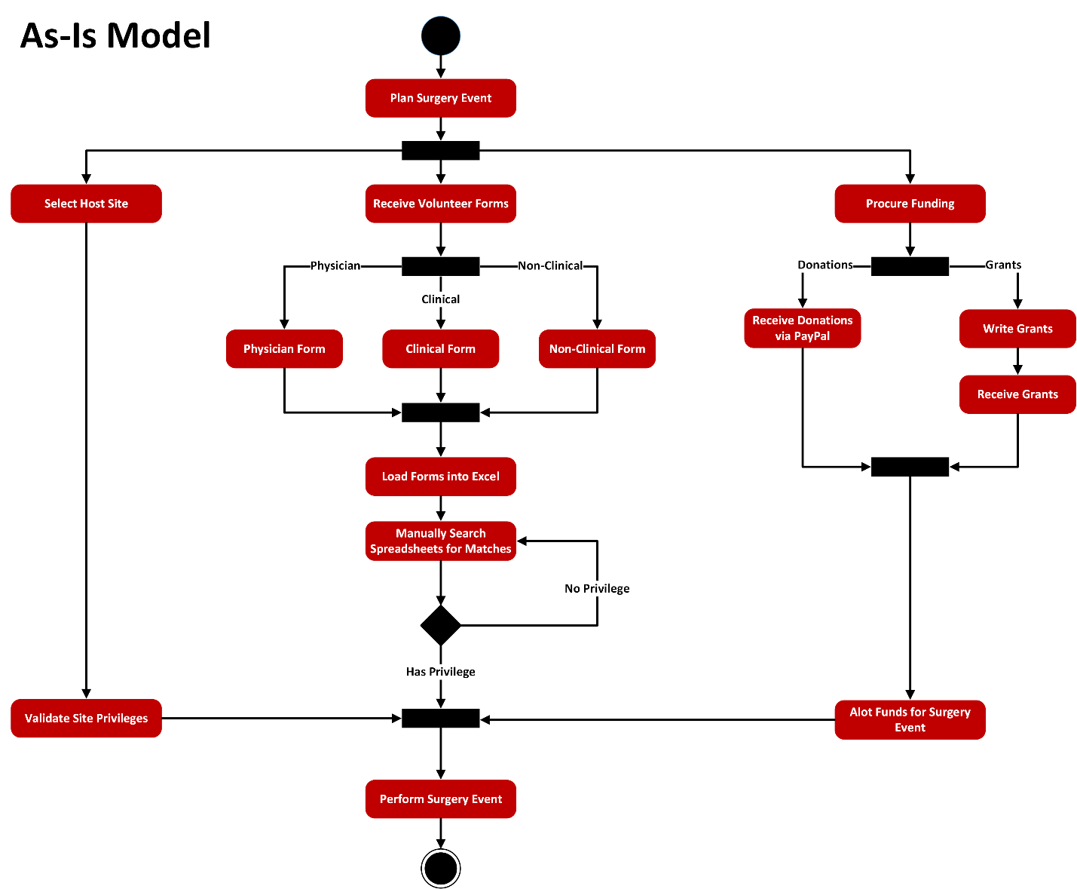

**To-Be Process Models:** The three primary processes in the creation of a surgery event will not be replaced, but rather refined for increased efficiency. A host location and its sites privileges will still be determined. The volunteer information (including location privileges) received and collected will be sorted and placed into a database. Volunteers will be selected via an SQL search query to quickly determine the participating and eligible volunteer for an event. The last process, the procurement of funds, will change in that all donor and grantor information will also be stored in the database to send out newsletters and thank-you letters to encourage additional donations. All three processes will join in the end for the creation of a surgery event. The new process will save a great deal of time by eliminating tedious processes, improve organization, and increase funds.

